- repo, ci/cd, API

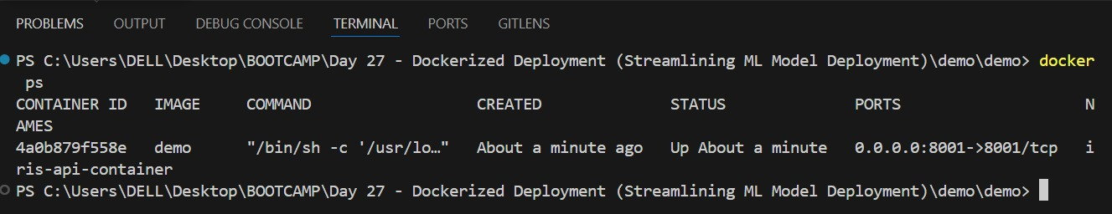

Digital Ocean

